OSPF Stub Areas

In this lab we will configure and observe the behavior of different types of OSPF stub areas. We will also test the functionality of the area range command.
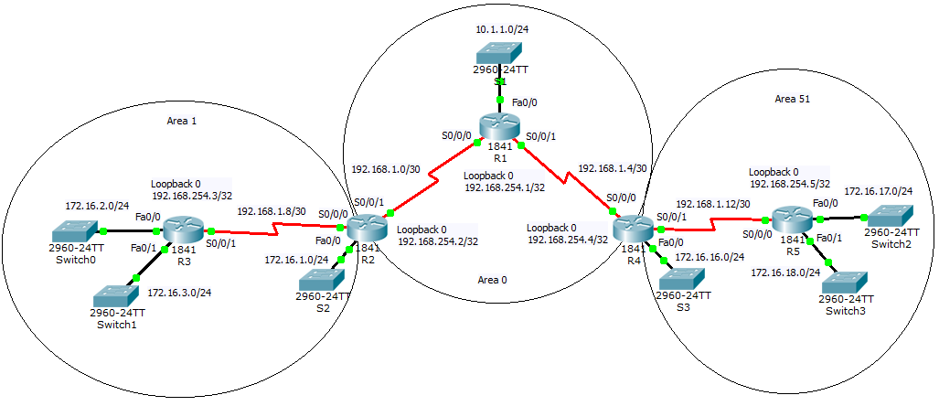
Note – Makes sure to save often in case of Packet Tracer issues.
Step 1 - Physical
- Open Packet Tracer and build the above topology.
- The routers can be 1841 or 1941 models. Ensure the HWIC-2T is inserted.
- Use 2960 switches
- There is no specification for which end of each serial link should be DCE

Step 2 – IP addressing
- Configure IP addressing as per the network diagram.
- Ensure to configure the loopback interfaces.

Step 3 – Basic OSPF
- Let the OSPF router-ids be set dynamically .
- Ensure the correct interfaces are running OSPF for the correct OSPF areas.
- Ensure all loopback interface networks are advertised within OSPF.
- Make all LAN interfaces passive.

Step 4 – Introduce an external route
- Configure a static null route on R3. This will be used to represent a foreign network. Note that all packets directed towards this network will discarded (by the Null interface). You would normally combine this with more specific routes to actual destinations, whereby the static null route is being used to create a summary address.
R3(config)#ip route 200.1.1.0 255.255.255.0 null 0

- In this example we are using the null route as a means to introduce an external network into OSPF through redistribution. Configure the following redistribution command on R3.
R3(config)#router ospf 1
R3(config-router)#redistribute static subnets

- Confirm the route has been redistributed into OSPF and propogated to R5. It will appear as an OSPF E2 route.

Step 5 – Baseline
- View the LSDB on R5 and record the results.
- What LSAs are present?
- Why are there no Type 2 Network LSAs?

Step 6 – Stub Area
- Configure Area 51 as a stub area
- Where is this done?
- What command/s did you use?
- View the LSDB on R5 and record the results.
- What LSAs are present?
- Is there a default route?

Step 7 – Totally Stubby Area
- Configure Area 51 as a totally stubby area
- Where is this done?
- What command/s did you use?
- View the LSDB on R5 and record the results.
- What LSAs are present?
- What happened to the Summary LSAs?

Step 8 – Not so Stubby Area
NSSA allow externals to be generated within a stub area as a type 7 LSAs.
- Configure Area 51 as a totally stubby area
- Where is this done?
- What command/s did you use?
- Create an external route by redistributing a static route into OSPF on R5
R1(config)#ip route 33.33.33.33 255.255.255.255 null 0
R1(config)#router ospf 1
R1(config-router)#redistribute static

- View the LSDB on R5 and record the results.
- What LSAs are present?
- View the LSDB on R4 and record the results.
- What LSAs are present?

Step 9 – OSPF External Routes
- So far we have created 2 OSPF external routes.
- What type of OSPF external routes are these?
- How is the cost calculated?
- Check the R3 route table and confirm the cost for 33.33.33.33
- Change the redistribution statement on R5 so that the external route is now E1
- How is the new cost calculated?
- Check the R3 route table and confirm the cost for 33.33.33.33

Extension
- Configure area 51 as a Totally Stubby Not so Stubby Area
- Configure MD5 authentication between all routers

